Journey Into True Worship
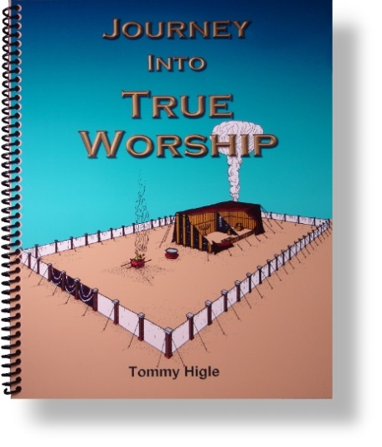
Because of the "worship wars" going on in many churches today, this 13-lesson study of the Tabernacle is essential. In the Tabernacle, God gives us a grand object lesson on true worship. Lesson titles include: God's Model for True Worship, Preparing To Worship God, The Only Way to God, Allowing the Altar To Alter Your Life, Requirements for Serving God, Getting Close to God, Brightening Your Light, Receiving Spiritual Food, Getting Your Prayers Answered, Before Entering God's Presence, Obtaining God's Mercy, Ministering to the Lord, and True Worship.

