Journey Into Living Wisely
In A Foolish World
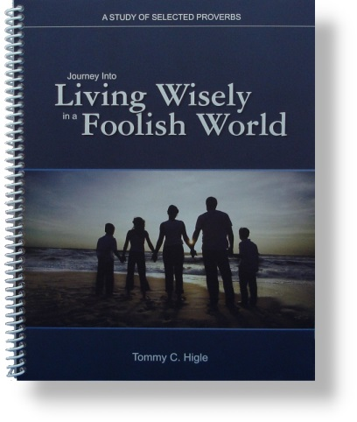
God has given us a book filled with wisdom about money, marriage, work, anger, stress, health, parenting, making friends, etc. It is called the book ofProverbs.
Lesson titles in this 13-lesson study of selected proverbs include: Becoming Wise, Help for Hotheads, Mastering Your Mouth, Finding Fantastic Friends, The Worst of All Sins, Leaving Laziness, Getting Out of Debt, Eliminating Envy, Wisdom for Better Health, Stifling Stress, Improving Your Marriage, Positive Parenting Principles, etc.

