Journey Into God's Applause,
Revised
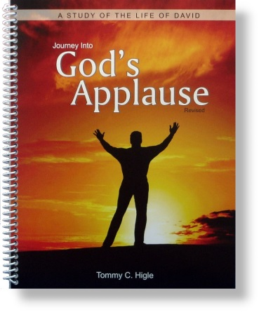
This is a new, 13-lesson study of the life of David, a man after God's own heart. Lesson titles include: How To Be Used by God, When You Face a Giant Problem, Dealing With Difficult People, When You Falter in Your Faith, Defeating Depression, Maintaining Good Character, Being a Person of Integrity, Doing Things God's Way, When God Says "No," Avoiding Sin, The High Cost of Sin, Sin's Horrible Harvest, and Winning God's Applause.

