Journey Into Knowing Jesus
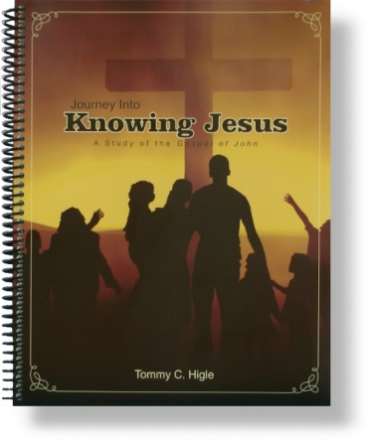
No book in the Bible helps us get to know Jesus better than the gospel of John. John didn't write his gospel to give us a lot of facts about Jesus, but so we can get to know Him and have a personal relationship with Him.
Lesson titles include: How Jesus Can Change You, Receiving a New Beginning, When You've Been Bad, Becoming a Bold Believer, Improving Your Spiritual Sight, Experiencing Resurrection Power, How To Please Jesus, Making Fear Disappear, The Ministry of the Holy Spirit, Benefits of Believing, Learning From the Shadow of the Cross, When Your Faith Falters, etc.

