Journey Into
Biblical Problem Solving
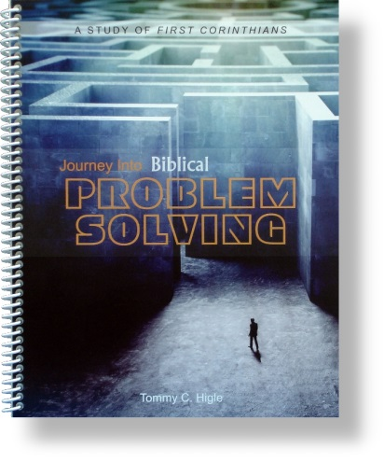
This is a 26-lesson, verse-by-verse study of 1 Corinthians, an epistle full of principles for solving all kinds of problems. Lesson titles include: Maintaining a United House, People God Uses, How To Receive Divine Wisdom, How To Handle a Church Scandal, Maintaining Moral Purity, Biblical Marriage and Singleness, When Something Right Is Wrong, How To Avoid Sin, How To Make Good Decisions, Understanding and Using Spiritual Gifts, Untangling Tongues, What Will Your Resurrected Body Be Like?, How To Build Up Your Church, etc.

