Journey Into Renewal, Revised
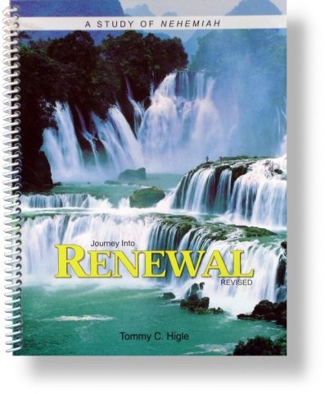
This 13-lesson study reveals the secrets for real spiritual renewal, using the book of Nehemiah as a model. Lesson titles include: Knowing When You Need Renewal, Essentials for Personal Renewal, How To Make a Tremendous Difference in Your Church, What Happens When Renewal Comes, How To Defeat Discouragement, Handling People Problems Wisely, Tactics Used To Derail Your "Journey," How To Know If You Are Spiritually Renewed, Experiencing Renewal Every Day, Living Supernaturally, Biblical Worship, and ABC's That Keep Old Sins From Reoccurring.

