Journey From Religion To Relationship
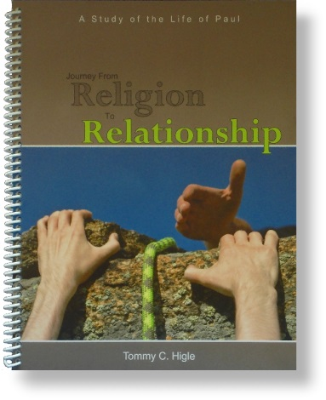
This title really sums up the life of the apostle Paul. God never intended us to have a dead, dull religion; He wants us to have a vibrant, active relationship with Him. This 13-lesson study covers Paul’s life as recorded in chapters 7-28 of the book of Acts.
Lesson titles include: When You Mess Up “Big Time,” Finding God’s Purpose for Your Life, Getting Ready To Serve God, Getting God To Bless Your Church, How To Be Usable for God, What To Expect as We Serve the Lord, Handling Life’s Frequent Problems, How People Respond to the Gospel, How People React When You Do God’s Will, When What You Believe Is Unpopular, How To Share Your Faith Effectively, What Your Should Know About the Storms of Life, and How To Finish the Race With Grace.

