Journey Into Righteous Living
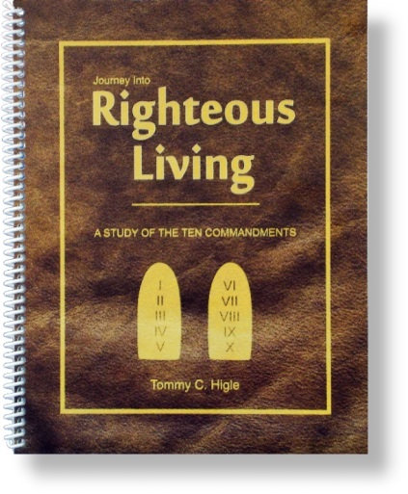
This is a 13-lesson study of the Ten Commandments. The first four commandments reveal how to have a right relationship with God and the last six how to have right relationships with people. They add up to a "journey into righteous living."
Lesson titles include: The Secret of True Happiness, Getting Your Priorities in Order, Avoiding Modern Idols, Using God's Name Properly, Preventing Burnout, Raising Kids Who Will Honor You, Alleviating Your Anger, Arming Him Against Adultery, Arming Her Against Adultery, Integrity Check-up, Truth or Consequences?, Finding True Contentment, and Obeying the Greatest Commandments.

