Journey Into Triumphant Living
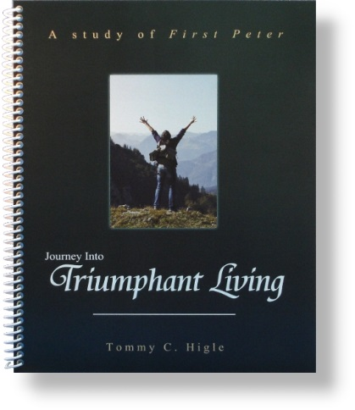
This new, 13-lesson study of 1 Peter reveals principles for living triumphantly during tough times. Lesson titles include: Dispelling Discouragement, The Benefits of Trials, How To Be Holy, How To Grow Spiritually, Influencing People for Christ, Improving Your Marriage, Changing Your World, Being Triumphant in Suffering, Living in the Future Tense, Preparing for the End, Rejoicing in Suffering, What God Requires When Life Is Tough, and Determining the Right Result of Suffering.

