Journey Into Victorious Living
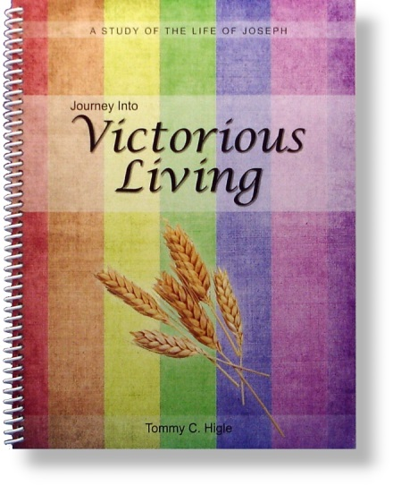
How can we be victorious over feelings of revenge, bitterness, and hatred? How can we find victory in the midst of life's problems and adversity? We find out in the life of Joseph.
Titles in this new 13-lesson study include: When Life Is the Pits, How To Terminate Temptation, When Life Seems Like a Prison, Getting the Most Out of Life, Maintaining a Clear Conscience, Living Worthy of Your Name, The Purpose of Our Problems, Principles for Peacemaking, Finding and Doing God's Will, Requirements for Victorious Living, Leaving a Lasting Legacy, When You Are Gathered to Your People, and Profiting From Your Problems.

