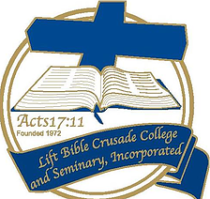

LIFT BIBLE CRUSADE COLLEGE AND SEMINARY, INCORPORATED
P.O. Box 833 Ocean Springs, MS 39566
Pastor Kenneth E. Hollins, PhD, Chancellor

www.liftbiblecollege.com

Correspondence Program Registration Form
Please complete and mail to the above address

Student Name: DOB: / /
Please print plainly

Address:

Phone Number:

Email:

Church Affiliation:

Pastor:

Education:

High School Attended:

College(s) attended and degree(s) received:

Please list the correspondence class or classes you wish to take. (see website)

“These were more noble than those in Thessalonica, in that they received the word with all readiness of mind, and searched the scriptures daily, whether those things were so.” Acts 17:11

