Journey Into Powerful Living
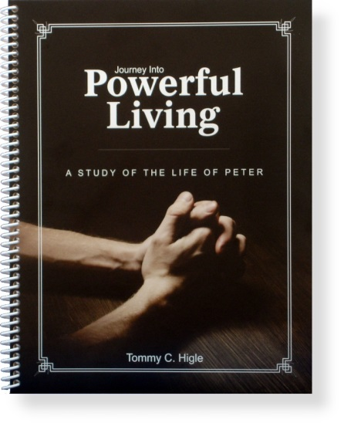
Same book, new cover! This 13-lesson study of the Life of Peter reveals the secrets for powerful living. Our Lord takes this obscure, uneducated, and hot-tempered fisherman and transforms him into one of the most prominent forces in church history.
Lesson titles include: Requirements for Spiritual Power, Why God Allows Storms in Our Lives, Getting the Most Out of Life, Becoming a Balanced Believer, Avoiding Spiritual Sinkholes, Coming Back Home to God, How To Receive Spiritual Power, The Anatomy of a Miracle, Becoming a Magnetic Christian, When God Is Working in Your Life, etc.

