Journey Into Becoming
All God Wants You To Be
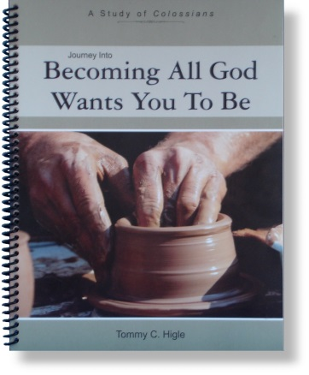
Colossians is short—only four chapters—but it is a power-packed book that tells us how to become all God wants us to be. Lesson titles include: The Trilogy for Spiritual Growth, Finding God’s Will for Your Life, Letting Jesus Fulfill All Your Needs, Having Your Own Successful Ministry, Growing in Christ, Why Jesus Is All We Need, Don’t Be Intimidated!, Victorious Christian Living, How To Dress for Spiritual Success, How To Have a Happy, Healthy, Home, Working God’s Way, Improving Your Communication With God and People, and How To Make Great Friends.

