Journey Through Revelation
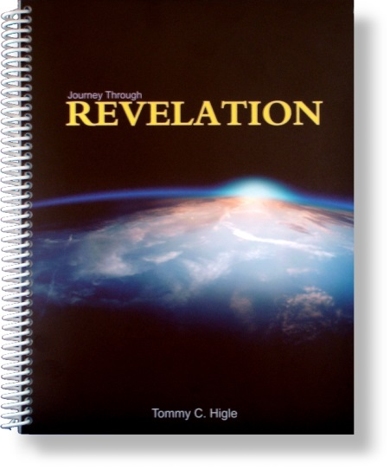
This is a 26-lesson study of Revelation. In this "journey," you will first be able to find yourself and your church in one of the seven churches. Then, through John's visions, you can take one of the most fascinating journeys in the Bible.
Lesson titles include: Getting the Most From This Study, When Life Is Tough, When You're Suffering, Avoiding Worldliness, When To Be Intolerant of Tolerance, Rekindling Your Spiritual Life, The Seven-sealed Scroll, The Four Horsemen of the Apocalypse, Six Key Personalities of the Great Tribulation, The Millennium and The Great White Throne Judgment, What Heaven Will Be Like, etc.

