Journey Into Faith That Works
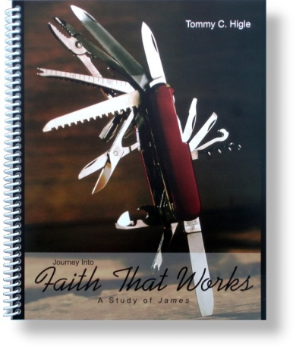
In this 13-lesson study of the book of James, you will discover how to deal with many of life’s issues, such as problems, temptation, money, prejudice, anger, misuse of the tongue, social injustice, etc. This epistle is basically a manual on having a "faith that works." Lesson titles include: The Purpose for Our Problems, Turning Down Temptation, How To Get the Most From the Bible, The Folly of Favoritism, How To Know You Are a Real Christian, Taming Your Tongue, Improving Your Relationships, Praying Powerfully, Conquering Conflict, Shunning the "Sins in Good Standing," Practicing Patience, and How To Manage Your Money Wisely.

